NWBT Investigator Folder Configuration

1. Go to the NWBT project RC folder
2. From the Admin menu, select Folder > Management and click the “Create Subfolder” button
3. Give the folder a name based on the investigator and choose the folder type "Collaboration"
4. Change the “Users / Permissions” setting to “Configure Later” and click the Finish button
5. From the Admin menu, select Folder > Management and click the “Folder Type” tab
6. Change the folder type to “NW BioTrust Specimen Requestor” and click the “Update Folder” button

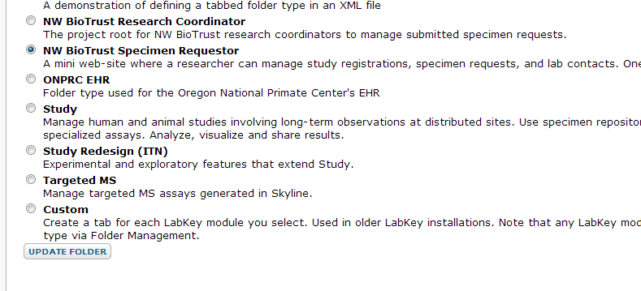

1. Click the “My Studies” tab
2. Click the “down arrow” icon next to the “Requestor Dashboard – My Studies” webpart title and select “Customize”
3. Select the “StudyRegistration” title checkbox and save